* 1.On the saved sample in e-commerce
* 2.I’ve created histogram following given instructions
* The following are outputs of final work.
* 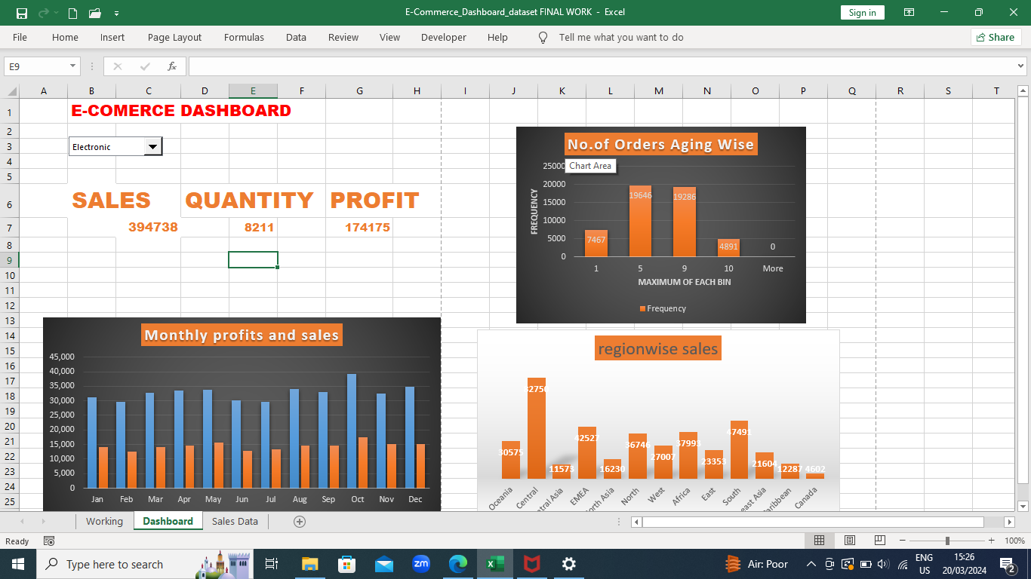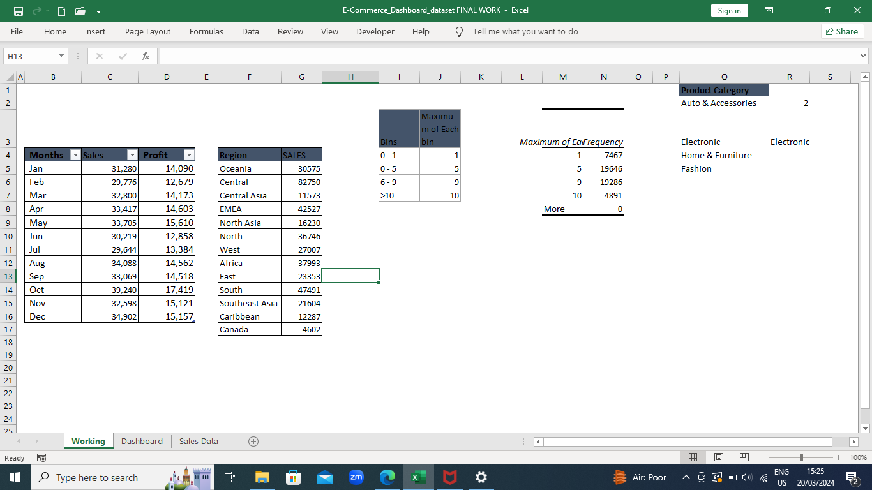

3.Prepared a table of sales and profit month-wise



4.Prepared the sale table region-wise



5.Created a user control combox for the product catergory using given instructions



Combo box



6.colum chart of month-wise table and region-wise table



7.linked the tables with the combo box

8. created a dashboard and calculated the predicted and actual tip values

9.calculated the RMSE OF THE MODEL



THEN COMBINED ALL MY WORK IN THE DASHBOARD TO MAKE IT ONE THING



AND ALL MY TABLES IN ONE WORKING SPACE

